How to build without libraries

Rayfire for Unity plugin supports runtime fragmentation and slicing for Windows, MacOS, iOS, Android and Linux platforms. Plugin provides libraries for every supported platforms that will go to build.

In case you do not use Runtime fragmentation or slicing in your game you do not need to have all these libraries in your build because they will increase your build size and they won't be used.

This instruction explains how to safely disable libraries from going to build, but you still will be able to fragment and slice objects in Editor.

- Open RFEngine.cs script in Assets\RayFire\Scripts\Classes\Shatter folder.
- Edit #if statement at line 7 and leave only UNITY_EDITOR symbol.
- Open RFShell.cs script in Assets\RayFire\Scripts\Classes\Shatter folder.
- Edit in the same way #if statement at line 70 and leave only UNITY_EDITOR symbol.
Now library code will be used only in Editor.
At next step you need to disable specific platform libraries in Inspector.
- In Project window in Assets\RayFire\Plugins folder select Android and Ios folders and delete them since these libraries are not used in Editor.
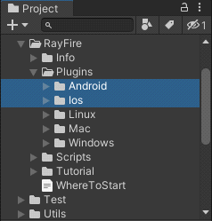
- If you work on Linux platform, select Mac and Windows folders and delete them.
If you work on Mac platform, select Linux and Windows folders and delete them.
If you work on Windows platform, select Linux and Mac folders and delete them, then open Windows folder, select x86 folder and delete it as well.
You should keep only libraries for platform that you are working on in Editor.
- In Project window select by one library file in the last folder of the platform that you are working on and in Inspector, under Select platforms for plugin caption disable Standalone property and leave enabled only Editor.

- After editing, click on Apply button.

After this procedure, you will be able to shatter objects in Editor using Rayfire Shatter component, but all runtime fragmentation features will not work in your game and library files will not be added in build.

